Overview of Harrow’s population and changes

Harrow’s main sources of population data are the Office for National Statistics (ONS) and the Greater London Authority (GLA).
The ONS produce the National Census every decade, the Mid-Year Estimates (MYE) annually and the Sub-National Population Projections (SNPP) approximately every two years; these datasets include births and migration data.
The GLA Demography Team produce a range of annually updated population projections at both borough and ward level for the 33 local authorities in the London region. Each round of projections includes a number of variants designed to meet a range of requirements, but in general variants form two groups:

- Borough Preferred Option (BPO). This is the default option but is dependent on boroughs providing development data to be incorporated into the projections.
- The latest GLA ward level Strategic Housing Land Availability Assessment (SHLAA) – capped AHS (average household size) population projections for all wards in the local authority. This is the option if boroughs have not provided their development data.

Harrow uses the GLA’s Borough Preferred Option, which are based on the latest available housing trajectory, to run our School Roll Projections on.

ONS 2011 National Census
Harrow’s population has been changing and increasing since the 2001 Census. A number of factors have contributed to this position; these are outlined in this document.
The 2011 National Census revealed that Harrow’s population is estimated to have increased to 239,100; this figure is 15.6% higher than the 2001 Census showed, and the ONS revised 2016 MYEs show a further increase to 248,697. Harrow’s population is now at the highest recorded level, based on records going back to 1901. The 0-4 age group has increased by 5,877 between mid- 2001 (12,058) and mid-2016 (17,935), which represents a 48.7% increase. There have also been increases across all the statutory school age groups.
The 2011 Census showed that Harrow’s residents were born in approximately 200 different countries and the percentage of Harrow’s residents born in the UK is the 6th lowest ranking nationally. Harrow is ranked 7th nationally (and in London) for ethnic diversity and 2nd for religious diversity in London.
ONS Population Projections and Estimates
Population Estimates (MYE) are the official source of estimated population size in between the censuses and inform a wide range of national statistics.
Population Projections (SNPP) provide statistics on potential future size and age structure of the population. They are based on past trends and assumptions of future levels of births, deaths and migration. They do not incorporate local development plans but instead provide a baseline, which can be combined with local knowledge.
The ONS’s Sub-National Population Projections project what the population of every local authority will look like over the next 25 years. It should be noted that all population projections become increasingly uncertain the further they are carried forward due to the inherent uncertainty of demographic behaviour.
The 2018-based SNPPs take the 2018 Mid-Year Estimates (MYEs) as their starting point, then: the population is projected forward a year at a time to 2041; the population is aged on from the previous year; the projected number of births and deaths are added; and adjustments for net migration are included. Births, deaths and migration are based on the trends observed in each local authority over the period mid-2011 to 2014. Finally the SNPPs are constrained to be consistent with the national projections for England.
GLA Borough Preferred Option Results for Harrow

Population Change
The population of Harrow is estimated to have grown by 10,661 persons (4.4 percent) between
2011 and 2019. Over the decade to 2029 the population is projected to grow by 14,6161 persons
(5.8 percent). By 2041 the population is projected to reach 272,536 persons, a 13.3 percent
increase on the 2011 population.

Table 1 below outlines the total population of Harrow from the census base population of 240,365 through five-year intervals to a projected 2041 population of 276,306.

Table 1: Population of Harrow
Year | 2019 Population
2011 | 240,499
2016 | 248,697
2021 | 250,230
2026 | 259,957
2031 | 267,788
2036 | 271,181
2041 | 272,536
Source: harrow_scenario_2_BPO_2019

Age structure
The greatest growth in Harrow, between 2011 and 2031, is projected to be in the 65 and over age group where the population increases by 16,605 persons (49.0 percent).

Table 2: Age structure of Harrow - 2019
Age Group | Population  2011 | Population  2031 | Change | Percentage  Change
0 to 3 | 13,252 | 13,100 | -152 | -1.1
4 to 10 | 20,315 | 22,207 | 1,892 | 9.3
11 to 15 | 14,892 | 16,794 | 1,902 | 12.8
16 to 25 | 31,644 | 31,020 | -624 | -2.0
26 to 64 | 126,510 | 131,859 | 5,349 | 4.2
65 and over | 33,886 | 52,808 | 18,922 | 55.8
Source: harrow_scenario_2_BPO_2019

ONS 2020 Mid Year Estimates (MYE)

Harrow’s population
Harrow’s population has increased from 240,499 in 2011 to 252,338 in 2020, increasing by 1,178 from 2019 to 2020.

Harrow | mid-2011 | mid-2012 | mid-2013 | mid-2014 | mid-2015 | mid-2016 | mid-2017 | mid-2018 | mid-2019 | mid-2020
Population | 240,499 | 241,978 | 243,004 | 245,149 | 246,818 | 248,697 | 248,880 | 250,149 | 251,160 | 252,338

Harrow’s population from mid-2011 to mid-2020
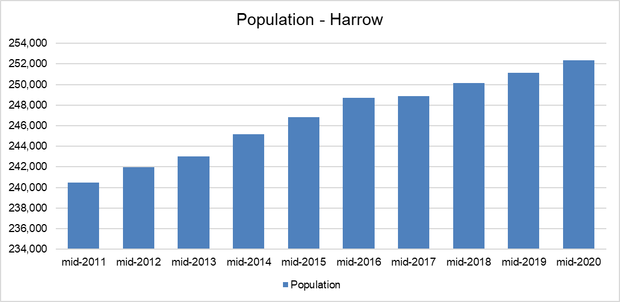
Harrow’s population increase between 2019 and 2020 (1,178) is slightly lower than it’s neighbouring London boroughs; Barnet increased by 3,138 and Hillingdon by 2,144. However, Brent and Ealing’s populations have dropped by 2,018 and 1,465 respectively.

Harrow’s births
Harrow’s births based on the ONS’s MYE have fluctuated between 2011 and 2018, peaking at 3,661 in 2015, and increased again in 2017 to 3,655 but have continued to drop since, falling from 3,543 in 2018 to 3,506 in 2019.

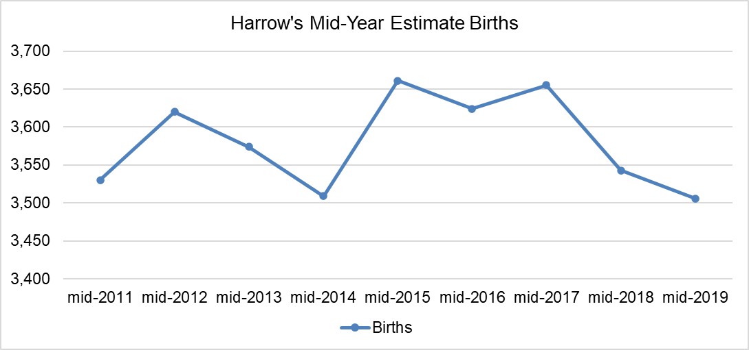

Harrow’s migration
Harrow’s internal migration resulted in a net loss of 4k people in 2017, 3.5k in 2018 and 2.1k in 2019. International migration resulted in a net gain of 3.2k people in 2017, 2.4k in 2018 and 1.7k in 2019. Net impact of total migration was a 834 loss in 2017, 1k loss in 2018 and 420 loss in 2019.

Harrow | 2017-MYE | 2018-MYE | 2019-MYE | Diff 2018-2019 | Direction
Internal in | 15,919 | 16,911 | 15,499 | -1,142 | Loss
Internal out | 19,955 | 20,369 | 17,637 | -2,732 | Loss
Internal net diff | -4,036 | -3,458 | -2,138 | 1,320 | Gain
International in | 4,631 | 4,345 | 4,022 | -323 | Loss
International out | 1,429 | 1,955 | 2,304 | 349 | Gain
International net diff | 3,202 | 2,390 | 1,718 | -672 | Loss
Overall net diff | -834 | -1,068 | -420 | - | -

ONS 2018-based Subnational Population Projections (SNPP)

Published on 24th March 2020, the SNPP suggest that the populations of all regions within England are projected to grow by mid-2028. All regions are projected to have a greater proportion of people aged 65 and over by mid-2028. London is still the largest growing region but no longer the fastest growing as it was in the 2016 SNNPs, it has dropped to 5th place in 2018.

Local Authorities

Population projections at local authority level are especially subject to annual local fluctuations in source data. Also, the actual local population change will be influenced by local economic development and housing policies.

Nearly all local authorities are projected to grow by mid-2028. Of the LAs with the highest projected population growth from 2018 to 2028 the only London borough is Tower Hamlets. Of the LAs with the highest projected population decline from 2018 to 2028 the only London borough is Ealing.

Harrow’s 2018-based SNPPs
Harrow’s population
The table below shows Harrow’s population over the next 10 years – it shows there is a very slow and steady increase from 2018 to 2028.

Year | Harrow Population
2018 | 250,149
2019 | 250,419
2020 | 250,751
2021 | 251,095
2022 | 251,350
2023 | 251,462
2024 | 251,467
2025 | 251,389
2026 | 251,371
2027 | 251,313
2028 | 251,337

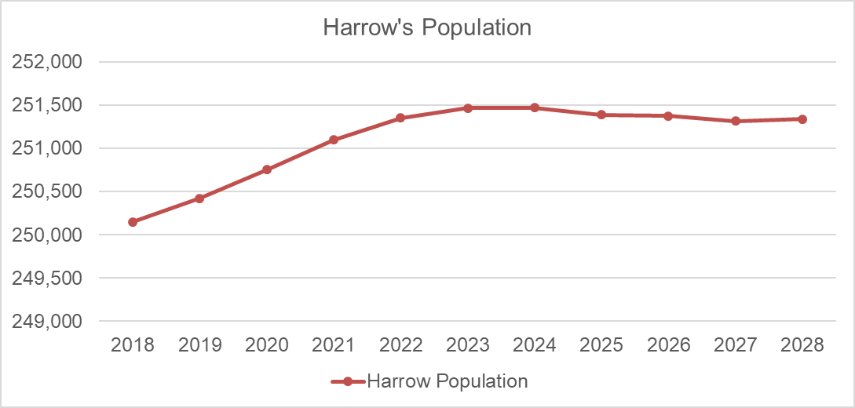

Harrow’s births
Harrow’s births are projected to fall from 3,260 in 2019 to 3,116 in 2023 and 2,970 in 2028.

Births | Harrow
2019 | 3,260
2020 | 3,248
2021 | 3,214
2022 | 3,167
2023 | 3,116
2024 | 3,048
2025 | 3,029
2026 | 3,009
2027 | 2,988
2028 | 2,970

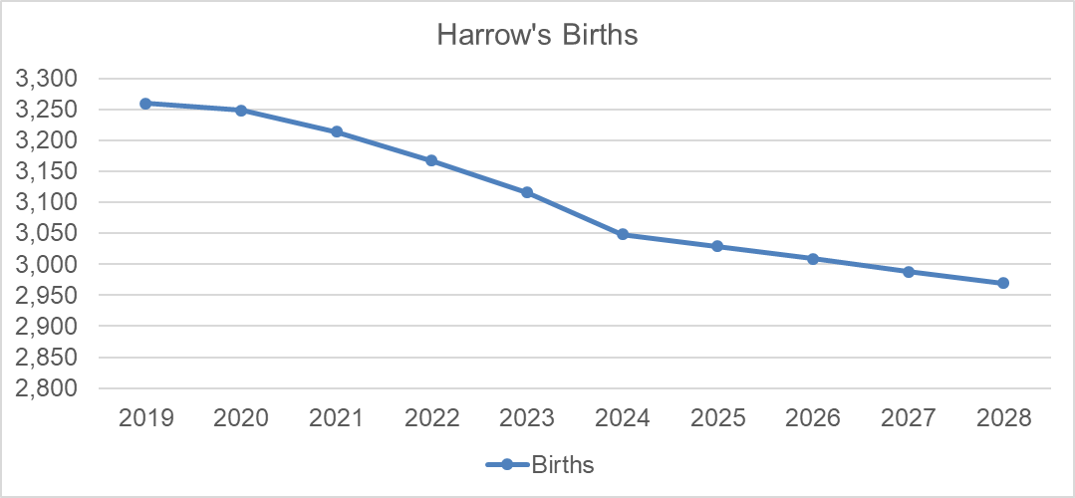

Harrow’s age ranges
The table below shows Harrow’s age ranges up to 90+. There is a projected drop in the 0 to 9 and 20 to 39 age ranges, with an increase for the remainder of the ages.

AGE GROUP | 2018 | 2023 | 2028
0-4 | 17,745 | 15,732 | 14,840
5-9 | 16,783 | 16,919 | 15,059
10-14 | 15,080 | 16,417 | 16,378
15-19 | 13,767 | 13,981 | 15,142
20-24 | 13,528 | 11,880 | 12,208
25-29 | 17,457 | 16,870 | 15,478
30-34 | 19,119 | 17,354 | 16,555
35-39 | 19,467 | 18,101 | 16,590
40-44 | 17,210 | 18,452 | 17,292
45-49 | 16,432 | 16,585 | 17,725
50-54 | 15,926 | 15,925 | 15,970
55-59 | 15,278 | 15,489 | 15,461
60-64 | 13,155 | 14,406 | 14,694
65-69 | 11,190 | 12,359 | 13,564
70-74 | 9,598 | 10,233 | 11,314
75-79 | 6,996 | 8,427 | 9,002
80-84 | 5,740 | 5,738 | 6,960
85-89 | 3,530 | 4,035 | 4,091
90+ | 2,148 | 2,560 | 3,017
All ages | 250,149 | 251,462 | 251,337

Migration
Harrow’s internal migration net loss of people has continued to drop over the last 4 years, as can be seen in the table below.

Harrow | 2016 MYE | 2017 MYE | 2018 MYE | 2019 MYE
Internal migration Net | -4,988 | -4,036 | -3,458 | -2,138

In contrast, International migration has resulted in a net gain, which has been dropping over the last few years, as can be seen in the table below.

Harrow | 2016 MYE | 2017 MYE | 2018 MYE | 2019 MYE
International migration Net | 3,035 | 3,202 | 2,390 | 1,718

The net impact of total migration in Harrow over the last four years has resulted in a loss of people, as can be seen in the table below.

Harrow | 2016 MYE | 2017 MYE | 2018 MYE | 2019 MYE
International migration Net | -1,953 | -834 | -1,068 | -420

The SNPP project a relatively steady picture regarding Harrow’s internal and international migration from 2018 to 2028

Harrow | 2018 | 2028 | Difference 2018-2028
All migration net | -1,505 | -1,257 | 248
Internal migration in | 15,469 | 15,420 | -49
Internal migration out | 19,893 | 18,952 | -941
International migration in | 4,900 | 4,094 | -806
International migration out | 1,892 | 1,725 | -167
Cross border migration in | 244 | 237 | -7
Cross border migration out | 334 | 332 | -2

Migration by age

The ONS SNPPs contain migration projections by age. Harrow’s net internal migration is overall projecting a loss of children of the following age ranges 0 to 4, 5 to 9, 10 to 14 and 15 to 19. There is projected gain for young people of the age range 20 to 24.

Internal net | 2019 | 2023 | 2028 | Direction
0-4 | -367 | -310 | -270 | Decreasing loss
5-9 | -367 | -383 | -332 | Decreasing loss
10-14 | -86 | -89 | -103 | Increasing loss
15-19 | -1,556 | -1,555 | -1,628 | Increasing loss
20-24 | 611 | 930 | 1,078 | Increasing gain

Harrow’s net international migration projects an increasing number of children migrating into Harrow for all the age ranges, however the increase is declining from 2019 to 2028.

International net | 2019 | 2023 | 2028 | Direction
0-4 | 294 | 260 | 243 | Decreasing gain
5-9 | 193 | 171 | 159 | Decreasing gain
10-14 | 171 | 151 | 141 | Decreasing gain
15-19 | 263 | 231 | 215 | Decreasing gain
20-24 | 484 | 408 | 368 | Decreasing gain

Overall net migration – there is a projected loss from 2019 to 2028 of the age ranges 0 to 4 and 5 to 9 and 15 to 19; and a projected gain of the age ranges 10 to 14 and 20 to 24.

Net | 2019 | 2023 | 2028 | Direction
0-4 | -73 | -50 | -27 | Decreasing loss
5-9 | -174 | -212 | -173 | Stable loss
10-14 | 85 | 62 | 38 | Decreasing gain
15-19 | -1,293 | -1,324 | -1,413 | Increasing loss
20-24 | 1,095 | 1,338 | 1,446 | Increasing gain

It should be noted that these projections are purely based on past trends, so any impacts that Brexit or the Covid-19 pandemic may have on future migration levels (or as a result of any other changes in government policies or economic circumstances) are not considered.

